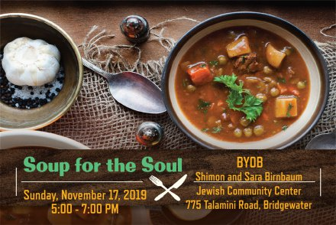

**Soup for the Soul**

**During the season of thankfulness, we invite you to share a bowl of delicious vegetarian and kosher soups as we recognize those in need. Break bread with us as we discuss ways that we can help eliminate Food Insecurity and social isolation in our community.**

**Program**

Welcome Helaine Weisberg

JFS Immediate Past President

JFS - Who We Are –What We Do Debby Feldman, Board Member

Food Insecurity & Social Isolation Maris Chavenson, LCSW, JFS Social Worker

The Food Bank Network of Somerset County, Inc. Marie Scannell, Executive Director

Raffle & Thank You Debby Feldman & Roxanne Levinston

Co-chairs of Soup for the Soul

**Soup for the Soul Mugs courtesy of Dr. Arthur and Mrs. Debby Feldman**

**JFS President**

Walter Yosafat

**Event Co-Chairs**

Debby Feldman & Roxanne Levinston

**Planning Committee**

Barbara Drew Olivia Edelman Sharon Margulies

Monica Skydell Kari Scaglione

For more information about JFS

[www.JewishFamilySvc.org](http://www.JewishFamilySvc.org) 908 725-7799

**Thank you to the Shimon and Sara Birnbaum JCC for hosting our Soup for the Soul Program today and the JFS Board and Staff and Volunteers who made this event a success!**

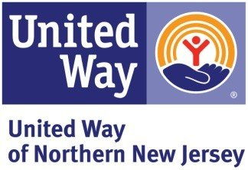  [](http://www.claimscon.org/index.asp)   